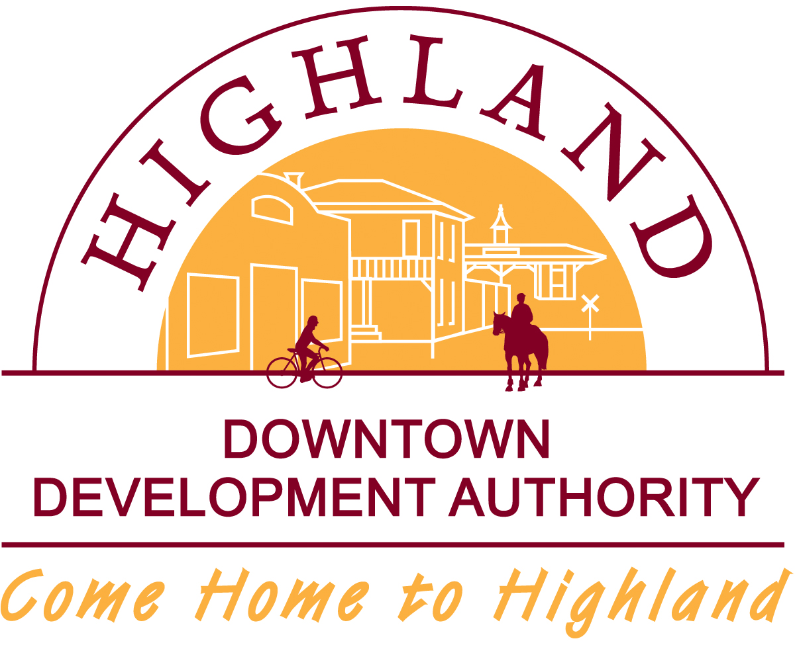

MEETING NOTICE

HDDA REGULAR BOARD MEETING

December 21, 2016

HAS BEEN CANCELLED

