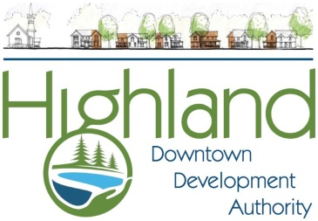

**Five Star Supply, Inc.**

Downtown Highland’s

Festival of Trees

**Sponsorship Contract:**

Please complete the following information and return to the Highland Downtown Development Authority. Please call the office with any questions at (248) 887-7200 or email [highlanddda@gmail.com](mailto:highlanddda@gmail.com)

Name (As you wish it to be listed in printed materials.)______________________________________________________

Contact Person______________________________________________________________________________________

*We prefer to correspond with everyone via email in order to expedite communication.

Contact person email: ________________________________________________________________________________

Billing address: _____________________________________________________________________________________

City/State: ________________________________________________________Zip: ______________________________

Business/Home Phone: _______________________________________________________________________________

**Payment Options: $85.00 per tree**

* Check Enclosed
* Please Invoice

**Tree Sponsorship Information:**

* $85.00 Sponsorship includes (1) 6’-0” to 7’-0” Pine tree and (3) Strands of Warm White LED Lights. If you wish to add additional lights they must be LED, and **cannot flash/blink/dance!** The trees will be installed the week of November 17th and will be available to decorate the week of November 24th. All trees must be decorated completely by December 2nd. Once all trees are decorated the public will vote and a “People’s Choice” Winner will be Crowned!
* You may pick up the number to your tree’s location and LED lights at Maher/Highland Feed and Supply in Downtown Highland Station the week of November 24th.
* Decorations MUST be tied or wired securely to your tree to resist high winds, rain, snow and vandalism. Regular ornament hangers do NOT work. All décor must be “family friendly” items.
* Thank you/recognition will be provided in local publication, online and on Facebook.
* Cut off for applications is Friday November 15th 2019.
* All decorations and lights must be retrieved by January 4th so the Highland Downtown Development Authority can dispose of the trees environmentally.

**I have read and understand the rules and guidelines for sponsoring a tree at the Highland Station Festival of Tree’s Event.**

Signature:__________________________________________________________________________________________

**Please make a copy of this page for your records and return original to:**

**Highland Downtown Development Authority**

**205 W. Livingston Road, Highland, MI 48357 or email highlanddda@gmail.com**