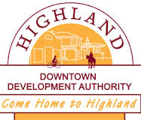
Highland Downtown Development Authority
Rental Subsidy Grant Program

The Highland Downtown Development Authority (HDDA) and Main Street Oakland County values our role that our downtown plays in making Highland a unique place to live, work, dine and shop. A strong Downtown enhances the quality of life for Highland residents while helping attract visitors to our community.

The HDDA Rent Subsidy Program is designed to provide assistance for (2) new key business activities (retail/dining/arts/entertainment) that choose to locate in our Downtown Main Street area. Additionally, there is also an opportunity for this program to assist existing businesses who require financial assistance. A total of (2) selected applicants will receive a (6) month rental subsidy, along with a one year membership with the Highland White Lake Business Association, (HWLBA).

In addition to completing this application, interested applicants are required to:

•Utilize Main Street Oakland County’s One Stop Shop Business Center to develop a business plan prior to acceptance into the program.
•Provide financial information related to the startup and operation of the business.
•Attend training/workshop opportunities that deal with a variety of topics including merchandise management, marketing, HR, finance, customer service, etc.
•Have regular established hours and participate in HDDA as well as HWLBA Events. (See list on next page)

Complete application packages must be submitted to the HDDA by the first day of each calendar month in order to be considered by the ER committee and HDDA Board Members.

To be considered for this program, the applicant must apply and submit the proposed location or existing location along with lease agreement. The applicant must also be in good standing with Highland Township, having all required permits and inspections. Not all applicants will be accepted into the program.

The applicant will be required to complete the following prior to the decision to award the grant and the initial disbursement to the landlord:

• Meet with and review business plan with MSOC
• Arrange a meeting with the ER Committee that will involve an application presentation.
• Provide a business plan and proposed budget, financials (for presentation only) and marketing plan (including social media marketing strategy).
• Have initial permits and inspections completed with Highland Township and Oakland County.
•Arrange a meeting with HDDA in first 3 months to review performance and set quarterly goals.

PROGRAM CONDITIONS:

- Applicant must work with the Business Center at MSOC to develop a business plan.
- Applicant will be open for business a minimum of 5 days per week and will participate in AND will be open for designated HDDA and Highland White Lake Business Association Events. (This includes extended hours as necessary).
Major events/activities required include:
•Ladies Night Out
•Summer Sidewalk Sales
•Founders Day Festival
•Retail Business Team
•Attend at least one monthly HWLBA Event/Mixer, etc.
- Applicant will obtain the services of a bookkeeper/CPA acceptable to the HDDA Board.
- If during the duration of the program the applicant fails to meet program requirements, the rent subsidy will not be applied.

SUBSIDY DETAILS:
Applicants are eligible for a 6 month rental subsidy that is as follows.
$400.00 per month plus a (1) year membership to the HWLBA

TOTAL: $2,500/ over a 6 month period

Priority will be given to:
- Retail/dining/attraction businesses located within the DDA district that benefit downtown Highland as a unique destination, and are Michigan based. No chains will be considered.
- Retail oriented businesses that are underrepresented within the current downtown business inventory.
- Businesses that will be located in critical vacancies as determined by the ER Committee.
- Must be located in the HDDA District. See map on next page for details.

Highland Downtown Development Authority District Map
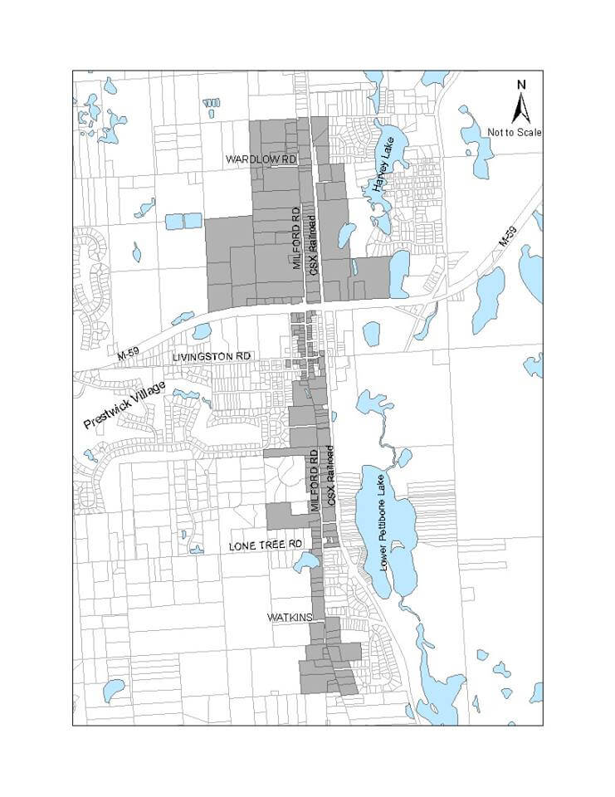
DDA boundaries are up & down Milford Road starting at Wardlow to the North and ending just before Rowe to the South. It also includes the Library to Save- A-Lot along M 59 and on Livingston from the railroad tracks to the Fire Hall.

Highland Downtown Development Authority
Rent Subsidy Program

Applicant: ________________________________________________________________________

Applicant Address: _________________________________________________________________

Applicant Phone: __________________________________________________________________

Applicant Email: ___________________________________________________________________

Business Name: ___________________________________________________________________

Tax ID #: ________________________________________________________________________

Proposed Location: ________________________________________________________________

Property Owner: __________________________________________________________________

Property Owner Phone: ____________________________ Email: ___________________________

Estimated Open Date: _________________________ Useable Square Feet: ___________________

Rental Amount: ____________________________________________________________________

Anticipated Hours of Operation:
M: _______ Tue: _______ Wed: _______ Thurs: _______ Fri: _______Sat: _______ Sun: ________

Approximate Cost to Open Business: __________________________________________________

Personal Investment: _______________________________________________________________

Bank or other financial commitment: ___________________________________________________

Building Rehabilitation Cost: _________________________________________________________

Major Capital Expenditure Cost: _______________________________________________________

Attached:

_____ Business Plan
_____ Letter from MSOC
_____ Copy of draft lease agreement that includes lease amounts and term of lease

Business Description:
________________________________________________________________________________
________________________________________________________________________________________________________________________________________________________________________________________________________________________________________________
________________________________________________________________________________
________________________________________________________________________________

Please list the names of the persons your business will be working with in the capacities of:
Attorney: ________________________________________________________________________

CPA: __________________________________________________________________________

And/or Bookkeeper: _______________________________________________________________

Does the owner of officer of the business leasing the space have a business or familiar
Relationship to the property being leased? Yes or No

If yes, please explain: _______________________________________________________________
________________________________________________________________________________
________________________________________________________________________________

Please initial:

Applicant Acknowledges and agrees that completing an application does not guarantee acceptance into the program and retailer shall not rely on acceptance into the program when making business decisions, including the lease of the rental property. Purchase of merchandise, hiring of staff, etc. _______

Applicant acknowledges that rental assistance payments will be sent monthly directly to the Landlord and not to the applicant._________

I have read and understand the guidelines for this program. I understand that an application for funding is not a guarantee of funding and disbursement of funds will be made in compliance with the terms of this program. I understand that approval is subject to the discretion of the HDDA Board of Directors. Further, I affirm that the information I have provided is true and accurate.

Signature_________________________________________________ Date ___________________

Submit the application and all available supporting documents to:

Highland Downtown Development Authority
Melissa Dashevich-Executive Director
205 West Livingston Road
Highland, MI 48357
highlanddda@gmail.com

This program is proudly presented by:

Thanks to the generous support of:

